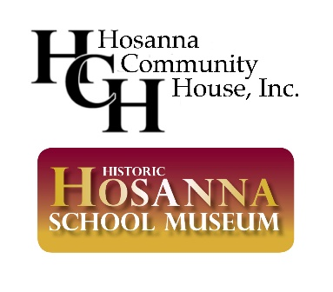

2021 JUNETEENTH CELEBRATION FESTIVAL
Organization/Corporate Sponsor Form

We, ___________________________, embrace the opportunity to enhance Harford County’s citizens understanding of and appreciation for the rich cultural history that has helped make it a fine place to raise a family.

We would like to:

______ be a BENEFACTOR with a contribution of $2,500 - $5,000
(Benefits: company logo on commemorative Juneteenth t-shirt, program banner, and emails advertising event; 7 ½ W x 4 ½ H ad in Juneteenth celebration booklet; and contribution noted on website)

______ be a FRIEND with a contribution of $1,000 - $2,499
(Benefits: company name listed on commemorative Juneteenth t-shirt, company logo listed on emails advertising event, contribution noted on the website and listed in Juneteenth celebration booklet)

______ be an ASSOCIATE with a contribution of $500 - $999
(Benefits: company name listed on commemorative Juneteenth t-shirt, company name listed on emails advertising event, contribution noted on website and program booklet)

______ be a SUPPORTER with a contribution of $250 - $499
(Benefits: contribution noted on website and program booklet)

_______________________________________________________________________

ORGANIZATION/COMPANY NAME
(Please provide title as preferred for publicity purposes)

_______________________________________________________________________
ADDRESS

CONTACT PERSON TELEPHONE NUMBER

The Board of Directors and Friends of Hosanna Community House Inc., doing business as Hosanna School Museum, thank you for helping us make Harford County an even better place to live, work, and raise our children by preserving and sharing the rich cultural history of Hosanna School Museum and McComas Institute.

Electronic Payment Options:
- Submit PayPal or Credit Card payment at www.hosannaschoolmuseum.org/donations/
- Send payment via CashApp at $1867Hosanna

If paying by check, make checks payable to Hosanna Community House, Inc. and mail to our treasurer, James Thornton.

James Thornton, Treasurer Direct questions to:
Hosanna Community House, Inc. Donna Lewis, Event Sponsorship Chair
P.O. Box 305 Darlington, MD 21034 410-802-0008
jthorn2@aol.com donnaelewis54@gmail.com

